

**EE464**

**STATIC POWER CONVERSION-II**

**Term Project Simulation Report**

**Grup ismi**

***Contributors***

Büşra Nur KOÇAK 1929355

Defne Nur KORKMAZ 2166858

Mustafa Mert Sarıkaya

Table of Contents

Introduction 3

Project Description 3

Topology Selection 3

Forward Converter 3

Flyback Converter 4

Analytical Calculations and Simulations 5

Transformer Calculations 5

Skin Effect 5

Ferrite Core Calculations 5

Component Selection 8

Power Losses 8

PCB Design 8

Conclusion 8

# Introduction

# Project Description

In this project, we are asked to design an isolated DC/DC converter in order to convert 220-400VDC input voltage to 12VDC with 100W output power. The specifications and requirement for the projects are following:

* Minimum Input Voltage: 220 V
* Maximum Input Voltage: 400 V
* Output Voltage: 12 V
* Output Power: 100 W
* Output Voltage Peak-to-Peak Ripple: 4%
* Line Regulation: 3%
* Load Regulation: 3%

# Topology Selection

## Forward Converter

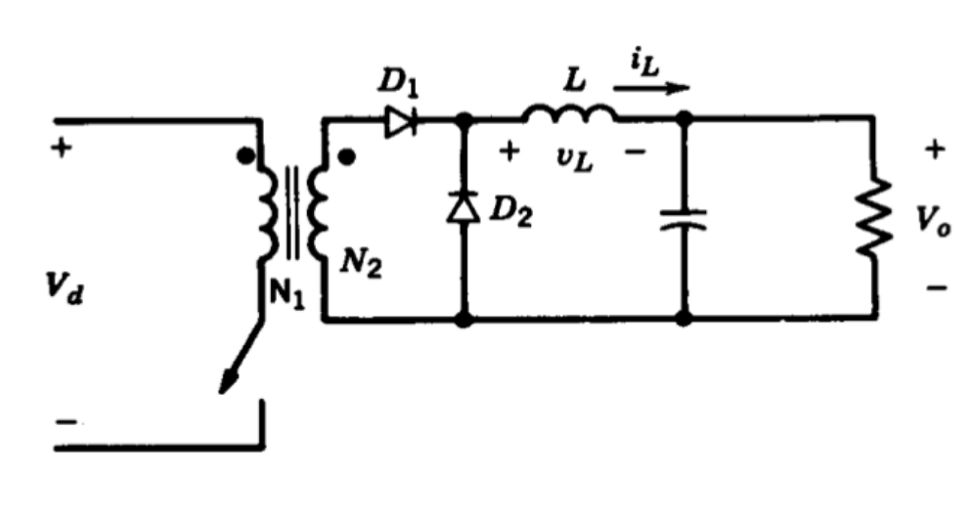

Figure 1: Forward Converter Topology

**Advantages:**

* Allows smaller transformer design than a flyback converter
* Better at isolated high-power applications
* Switching device has less voltage stress across it
* Low power losses and noise
* Does not require any snubber circuit

**Disadvantages:**

* The transformer core must be freed from unintentionally stored energy with each cycle
* Requires additional inductor at the output side
* More expensive
* Harder to control

## Flyback Converter

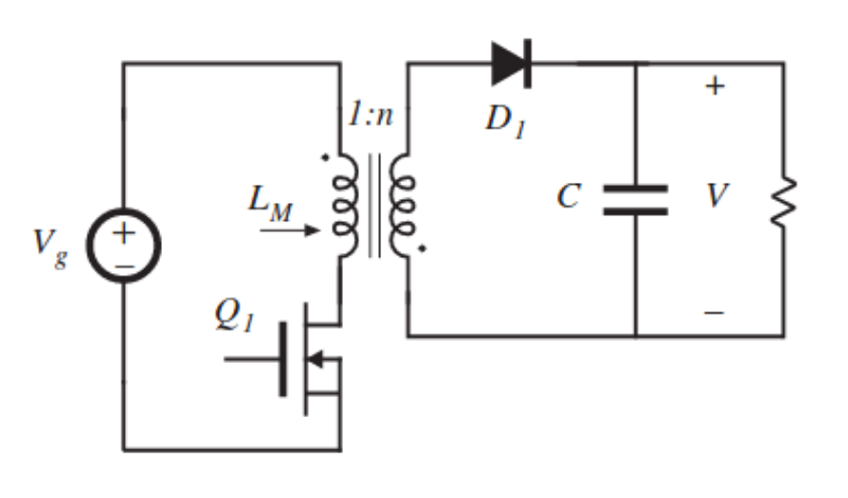

Figure 2: Flyback Converter Topology

**Advantages:**

* Better utilization of transformer
* Output inductor and diode ensure continuous output current
* More efficient to filter out high-frequency components
* Easier to control
* DCM operation allows soft switching
  + Allows to use smaller transformer core
  + Reduce switching losses

**Disadvantages:**

* Higher voltage stress across the MOSFET
* Gain changes a lot in DCM operation

Forward and Flyback converter topologies have been considered and examined in detailed while deciding on the topology which will be used in the project. According to the advantages and disadvantages of the both topologies, it has been decided to work on the Flyback converter design. While making the topology selection, some of the important factors have been evaluated as providing easier control of the converter and finding isolated controller options that meets the project requirements. In addition to these, the difficulty of controlling the forward converter and the possibility of causing problems in cases where the energy on the transformer could not be discharged regularly, made it certain to prefer the flyback converter topology.

# Analytical Calculations and Simulations

## Transformer Calculations

In an isolated flyback converter design, the core selection completely depends on the operating frequencies. As the operating frequency increases, maximum flux density created will decrease; therefore, increasing operating frequency is an advantage to prevent saturation in the core and also helps to use smaller core structure with increased efficiency. Smaller transformer core also helps to decrease the cost and size of the converter with a considerable amount. Therefore, the calculations of the transformer have been conducted considering 100kHz operating frequency, even though it will be adjusted by the flyback controller itself.

Moreover, operating region is also an important factor while deciding the size of the transformer core, where DCM operation allows to design smaller transformers by limiting flux density in the core and prevents from the saturation problems. Therefore, DCM operation has been assumed to be used in the design while calculating transformer values and dwell time duty ratio () is assumed to be 0.1.

In the first transformer design of the process, ferrite cores with an additional gap will be considered using Kg method, which allows to calculate required air gap, fringing losses and the cable losses in the transformer design. Moreover, this method allows to count the required strands number for the Litz wire design according to the selected core properties.

## Skin Effect

Operating frequency of the transformer is a primary property while deciding the cable size, which will be used during the design. Increasing operating frequency will cause current to flow from more outer part of the cable. Therefore, the middle part of the cable will be useless in the conduction period and this will cause increase in the resistance values. Considering this relationship between the frequency and cable size, it is preferred to design the transformer cables as Litz wire with multiple strands by calculating the number of layers which should be used for primary and secondary sides. Considering this perspective, calculating the skin depth for 100kHz gave an important clue while deciding the size of the cable which will be layered.

|  |  |  |
| --- | --- | --- |
|  |  | [1] |

According to the calculation done in the [1], it had been decided to use #26 AWG wire as base wire while designing the Litz wire size and number of layer requirements.

## Ferrite Core Calculations

The first specification which should be considered while designing the transformer for flyback converter is that the energy storage capability of the core. Therefore, the inductance needed for the storage of a specific amount of energy storage is also important.

|  |  |  |
| --- | --- | --- |
|  |  | [2] |

As the name suggest value, which is a core geometry values includes both energy requirements of the transformer application. Therefore, this value has been calculated first to decide the limiting value for the power handling capacities of the core selection.

|  |  |  |
| --- | --- | --- |
|  |  | [3] |

Considering both the value, saturation conditions of the ferrite cores, window area, permeability and inductance value per , EE-21 core have been chosen to be the core of the transformer design to continue with the calculations.

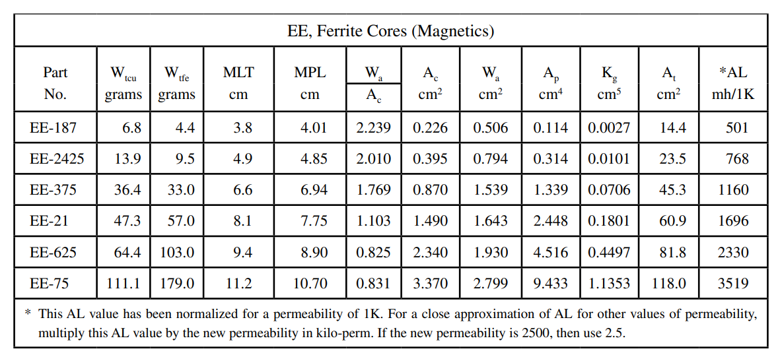

Table 1: Design data for EE ferrite cores

Before getting into the core calculations, the peak and rms values of the primary current have been calculated for the future calculations considering both current density in the core and strands numbers required for the transformer design.

|  |  |  |
| --- | --- | --- |
|  |  | [4] |

Moreover, the values of the selected core structure have been used to calculate the current density, wire area in the core, required number of strands and number of turns with the Equations [5], [6], [7], [8].

|  |  |  |
| --- | --- | --- |
|  |  | [5] |

: Maximum flux density, [T]

: Area Product, []

: Window utilization, 0.29

|  |  |  |
| --- | --- | --- |
|  |  | [6] |

: Primary wire area

|  |  |  |
| --- | --- | --- |
|  |  | [7] |

: Required number of primary strands

|  |  |  |
| --- | --- | --- |
|  |  | [8] |

: Window area of the core

: Number of primary turns

Because of the high permeability values of the ferrite cores, storing the required energy in the core requires some additional gap. Calculation of the additional gap for storing previously specified energy value can be observed from Equation [9].

|  |  |  |
| --- | --- | --- |
|  |  | [9] |

: Iron area

: Magnetic path length

: Permeability of the core material

It should be also considered that even though adding a gap to increase the energy storage capability of the ferrite core is a preferred method at some cases, it has some disadvantages as fringing flux. Therefore, this effect should be also calculated to consider its effect on the power loss of the transformer design.

|  |  |  |
| --- | --- | --- |
|  |  | [10] |

Moreover, the fringing flux also has an effect on the number of required turns in the primary side of the transformer and the peak flux density as follows.

|  |  |  |
| --- | --- | --- |
|  |  | [11] |

: New number of turns for the primary

|  |  |  |
| --- | --- | --- |
|  |  | [12] |

: Magnetic path length

As the number of turn and strands values of the primary have been completed, ESR resistance of this side can be also determined by considering both the designed Litz wire strands, #26 AWG copper wire resistance property, number of turns in the primary and the magnetic path length of the selected core.

|  |  |  |
| --- | --- | --- |
|  |  | [13] |

Moreover, secondary side of the transformer can be calculated with the values, which have been calculated so far. Decided duty cycle and dwell time duty ratio plays an important role while calculating the secondary side of the transformer. Moreover, the voltage drop on the output part of the flyback converter is assumed to be 1V during the calculations.

|  |  |  |
| --- | --- | --- |
|  |  | [14] |

Other than the turn number of the secondary of the transformer, same calculations have been applied to calculate secondary peak current, rms current, wire area, secondary strands number, and winding resistance.

# Component Selection

# Power Losses

# PCB Design

# Conclusion